## **What are Git and GitHub?**

Git was developed in 2005 by Linus Torvalds as *open source software* for tracking changes in a *distributed version control system*.

Git is open source because its source code is made freely available for anyone to modify and use, aside from its creator. Open-source projects are built and maintained collectively by different developers in different locations.

Git track changes via a distributed version control system. This means that Git can track the state of different versions of your projects while you're developing them. It is distributed because you can access your code files from another computer – and so can other developers.

When you're building an open source project, you'll need a way to document or track your code. This helps make your work organized, and lets you keep track of the changes you've made. This is what Git lets you do.

But you also need a place to host your code – which makes controlling each version of your project easier and faster. This is where GitHub comes in.

GitHub is a "hub" (a place or platform) where Git users build software together. GitHub is also an hosting provider and version control platform you can use to collaborate on open source projects and share files. When you're using GitHub, you're working with Git beneath the hood.

## **Why Should You Learn Git and GitHub?**

According to Techmonitor.ai, over 73 million developers use GitHub as of November 2021. And the GitHub community is set to hit 100 million users by 2025.

As you can see, millions of people all over the world use these tools, and the numbers just keep going up.

Because of this, more companies are requiring new hires to know how to use Git and GitHub. So if you're looking for a developer job, these are essential skills to have.

If you're not using Git and GitHub, it's clear – you should be!

## **Differences between Git and GitHub**

Git is a version control system that manages and keeps track of your code. GitHub, on the other hand, is a service that let you host, share, and manage your code files on the internet.

GitHub uses Git underneath, and lets you manage your Git repositories or folders easily on its platform.

So Git is the actual version control system and GitHub is the platform where you host your code.

If you want to learn more about the differences between these two tools, you can [read this tutorial](https://www.freecodecamp.org/news/git-and-github-overview/).

## **How to Start Using Git and GitHub**

### **Step 1 – Install Git**

Git comes preinstalled in some Macs and Linux-based systems, but you can always check if you have Git installed in your machine by typing git version in your terminal. You can use the Command Prompt to do this.

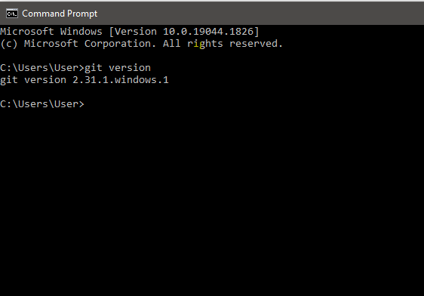

As you can see above, I have Git version 2.31.1 installed on my Windows computer. If you don't have Git installed in your computer, you won't get a version.

You can download Git [here](https://git-scm.com/download) and then select your operating system to download.

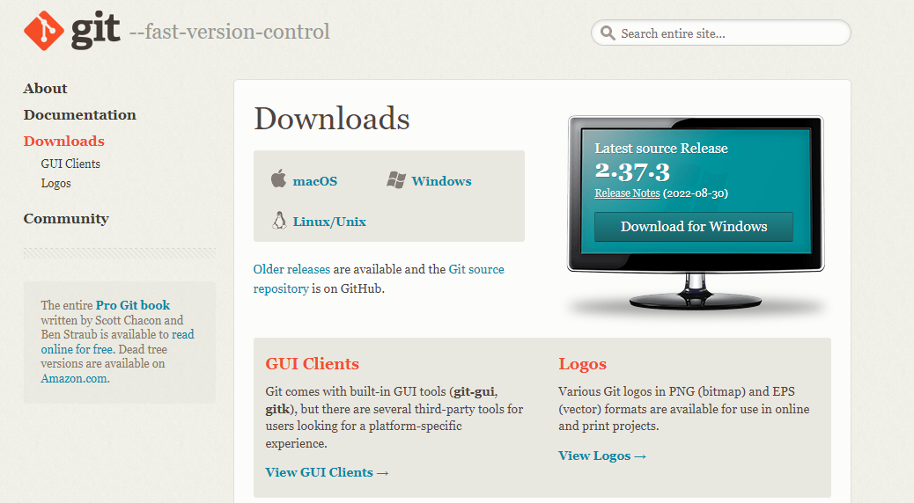

Follow the necessary installer guide until installation is complete. Open the command prompt and type git version to verify that Git was successfully installed.

### **Step 2 – Create a GitHub Account.**

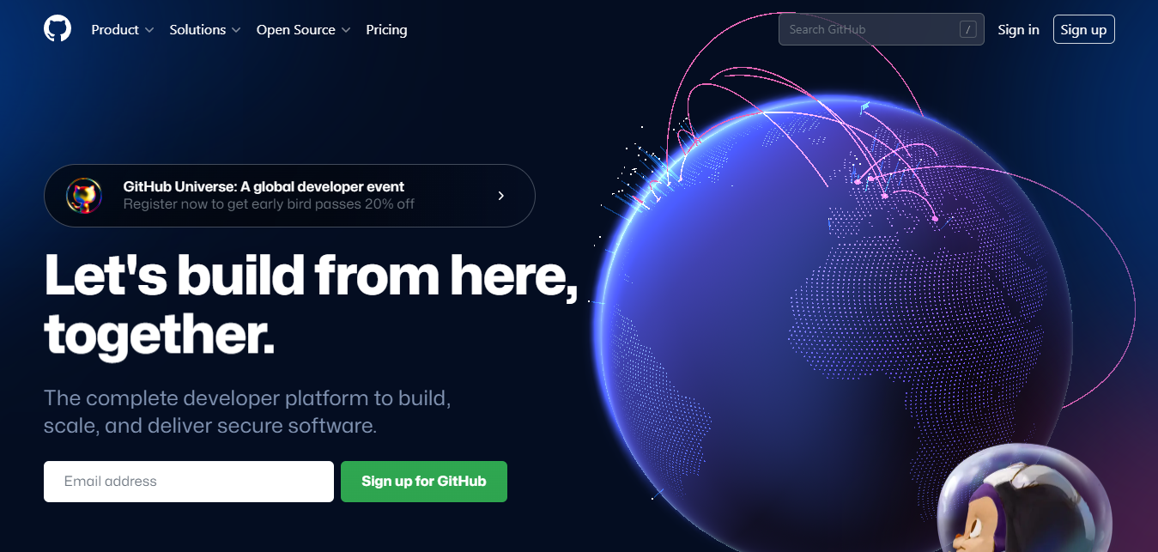

To create an account on GitHub, you will be asked for some personal information like name, confirm your email, set a username and password, and your account should be set up in minutes.

Create an account on [GitHub.com here](https://github.com/).

### **Step 3 – Connect your GitHub account to your Git account.**

You'll do this from your terminal.

To set your Git username, type this in your terminal:

git config --global user.name "Segun Ajibola"

To confirm that you have set your Git username correctly, type this:

git config --global user.name

You should have "Segun Ajibola" as the output.

To set your Git email, type this in your terminal:

git config --global user.email "youremail@gmail.com"

To confirm that you have set your Git email correctly, type this:

git config --global user.email

You should have "youremail@gmail.com" as the output.

You will be asked to authenticate your GitHub account, so just sign in with the same email to confirm.

### **Step 4 – Create and edit your code files locally**

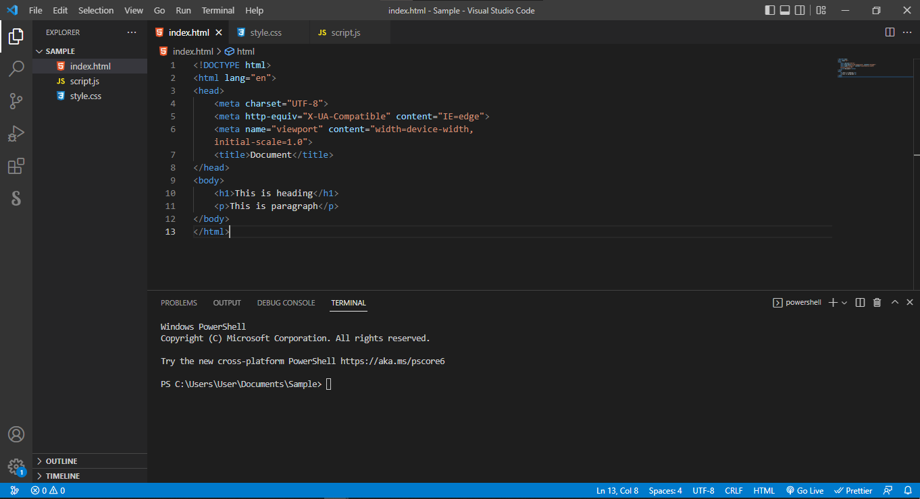

### **Step 5 – Create a repository on GitHub**

Click the + sign at the top right corner to create a new repository. Repositories are like your code folders online.

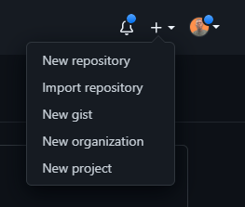

You will be prompted to this page:

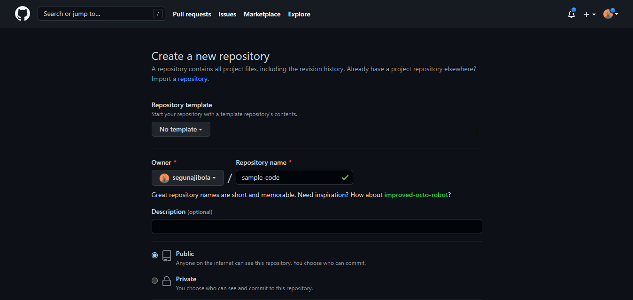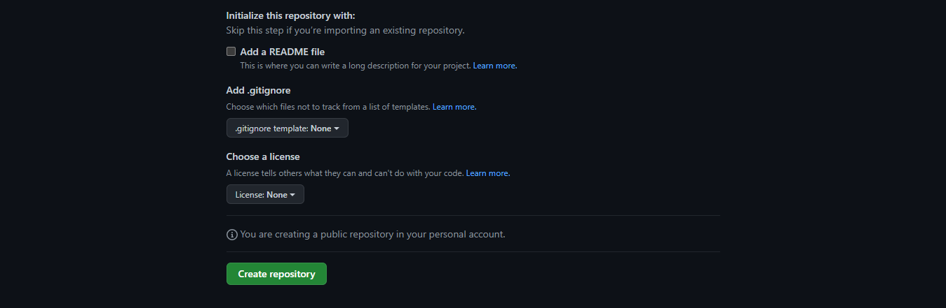

Name your repository and give it a description (this is optional).

Click the "Create repository" button to create the repository. You will be prompted to this page:

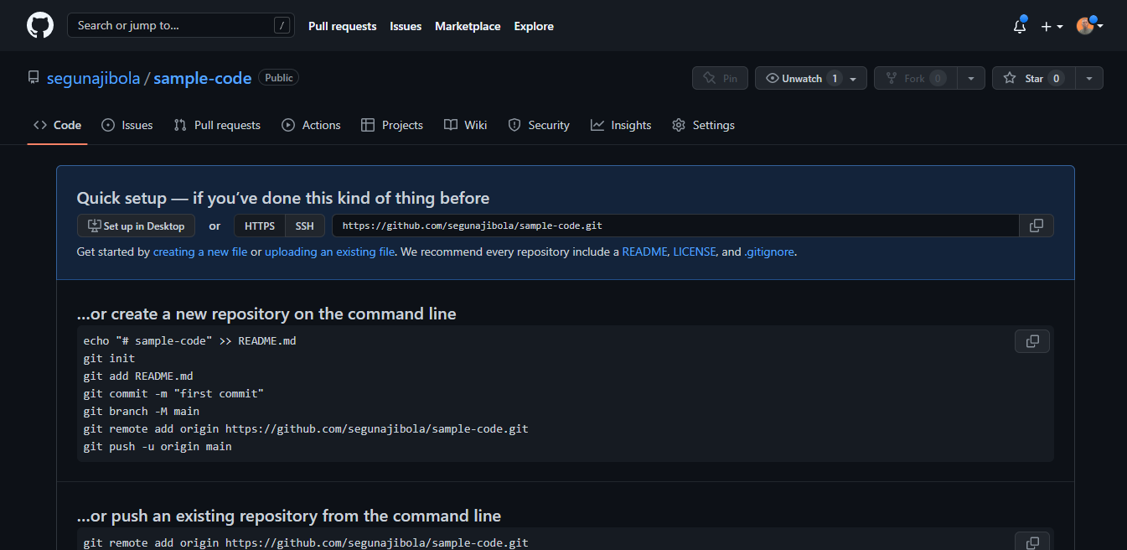

### **Step 6 – Push your local code to GitHub**

You can use the code editor built-in terminal to use Git to push your code to GitHub. Click ctrl + shift + ' to open the terminal in VSCode.

Input the commands below one after the other in your terminal. Press the Enter key to proceed after every input.

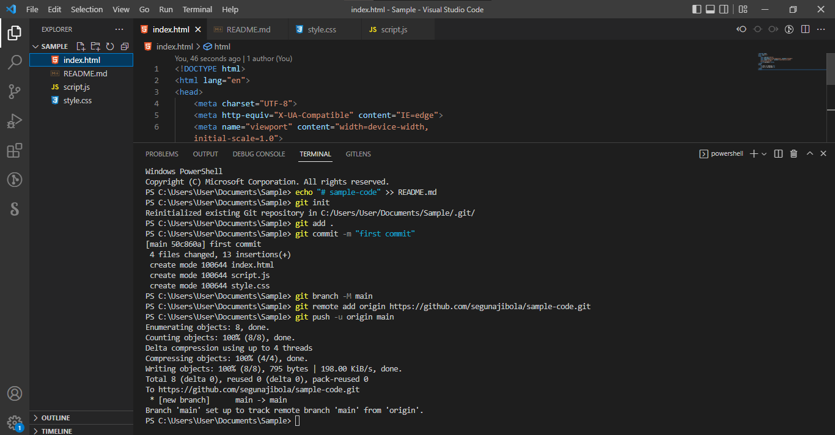

‌echo "# sample-code" >> README.md

1. Generate the token (Settings🡪 Developer Settings🡪Token classic 🡪 token name(copy the token and save it locally)
2. Create a new Java project (LearningJava) 🡪 create a package (basics)🡪 create HelloWorld.java
3. Go to the LearnJava Project folder🡪 type cmd in the address bar🡪 cmd will open

git init

git add .

converting the working copy into local copy

git commit -m "first commit"

git branch -M main

git remote add origin https://github.com/segunajibola/sample-code.git

//To forcefully pull the code from the remote github repository

git pull origin main –allow-unrelated-histories

pushing the local copy to the remote copy (github)

git push -u origin master

Note that we have git add README.md in the repository on GitHub. But here we have git add ., which is to let Git add all our code files instead of the README.md file which will be created by echo "# sample-code" >> README.md. So if you have created other files in your local folder, you need to use git add . to add all files.

Take note that git remote add origin <https://github.com/segunajibola/sample-code.git> will contain the link to your own repository and it will have have the name of your GitHub account.

## **Common Git Commands to Know**

They are many Git commands you can use in the terminal, and that can get overwhelming. So I'd suggest focusing on some of the most popular ones first.

Here they are:

git init lets you initialize Git in your folder.

git add [Readme.md](https://readme.md/) lets you add the Readme file, while git add . lets you add all files in the present folder.

git commit stores the added files. Use -m for message followed by the actual message.

git branch creates a new branch which is a new version of the repository as it appears when added, and -M to move the name to main.

git remote add origin finally connects the local folder to the repository on GitHub. It is followed by the repository's link.

git push -u origin main pushes the code to GitHub. The -u flag creates a tracking reference for the branch, and origin main puts the code in the main branch.

// create a branch and switch to the branch

$ git checkout -b <branch-name>

// create a branch only

$ git branch <branch-name>

Source: https://www.freecodecamp.org/news/introduction-to-git-and-github/